Completion of Burn down Chart Sprint One, Sprint Two, Release One

As these images are copied straight out of the Google Doc, it doesn’t keep the ability to edit the data input.

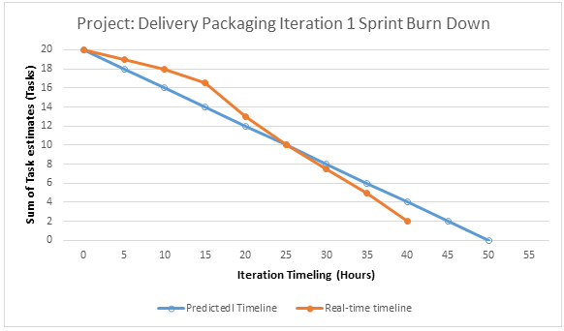

Sprint One Burndown Chart

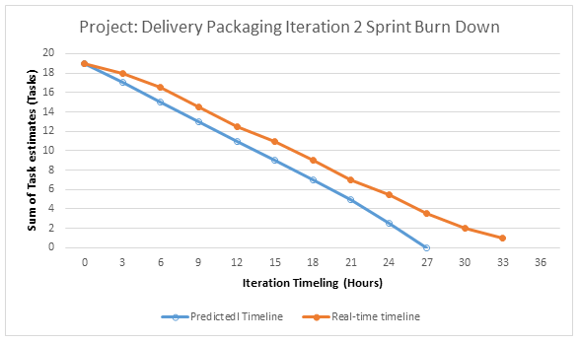

Sprint Two Burndown Chart

Sprint Release One

